Practical - 3
Practical Title: Responsive UI Design using CSS Grid, Flexbox, and Bootstrap/Tailwind
Problem Definition: Design responsive layouts for Home, About, Registration, Dashboard, and Events pages using CSS Grid and Flexbox. Optional to use CSS framework such as Bootstrap or Tailwind. Ensure mobile-first responsiveness.

Theory

How does the layout adapt for mobile, tablet, and desktop screens?
Answer: Adaptive layouts use flexible grids, responsive design concepts, and media queries. These techniques allow the layout to adjust according to the device’s screen width, height, and orientation.
- Responsive Design Concepts: Use flexible grids, layouts, and images so that content adjusts properly to different screen sizes.
- Media Queries: Apply different CSS styles based on device characteristics such as screen width, height, orientation, and resolution.
- Responsive Breakpoints: Define breakpoints for common device sizes. The interface automatically adjusts its layout when the screen width crosses these breakpoints.

Reference Link: https://developer.android.com

Which layout technique is used and why?
Answer: The Student Hub Portal uses CSS Flexbox and Grid to create a responsive and well-organized layout.
- Flexbox: Used for the sidebar, navigation bar, buttons, and alignment of elements. It makes it easy to arrange items horizontally or vertically.
- CSS Grid: Used for the dashboard cards and main content sections, allowing multiple cards to be arranged in rows and columns.
- Media Queries: Used to make the layout responsive for mobile, tablet, and desktop screens.
These techniques make the Student Hub layout flexible, organized, responsive, and easy to maintain across different screen sizes.

3. Are typography, spacing, colors, and contrast readable?
Answer: Yes, the Student Hub Portal uses readable typography, proper spacing, suitable colours, and good contrast.
- Typography: Poppins font is used for a clean and modern appearance.
- Spacing: Proper padding and margins provide enough space between sections and elements.
- Colours: A consistent colour palette is used throughout the website.
- Contrast: Dark text on light backgrounds and clear button colors make the content easy to read.
- Overall: The design provides a clear, comfortable, and user-friendly reading experience across different screen sizes.

4. Is the framework used consistently without unnecessary inline CSS?
Answer: Yes. The Student Hub Portal uses CSS consistently through the external style.css file instead of adding unnecessary inline CSS.
- External CSS: Common styles are maintained in the style.css file.
- Consistency: The same colours, fonts, spacing, buttons, cards, and layouts are reused across pages.
- Less Inline CSS: Inline styles are avoided to keep the HTML clean and easier to maintain.
- Reusable Classes: CSS classes are used to apply the same design to multiple elements.
Overall: The use of an external stylesheet makes the website organized, consistent, reusable, and easier to update.

Implementation/ Output/Result
Properties Used
display: flex, display: grid, grid-template-columns, gap, flex-direction, justify-content, align-items, padding, margin, width, max-width, height, background-colour, colour, font-family: Poppins, font-size, font-weight, border, border-radius, box-shadow, position, overflow, text-align, transition, transform, @media.

Evidence of Work (Screenshots)
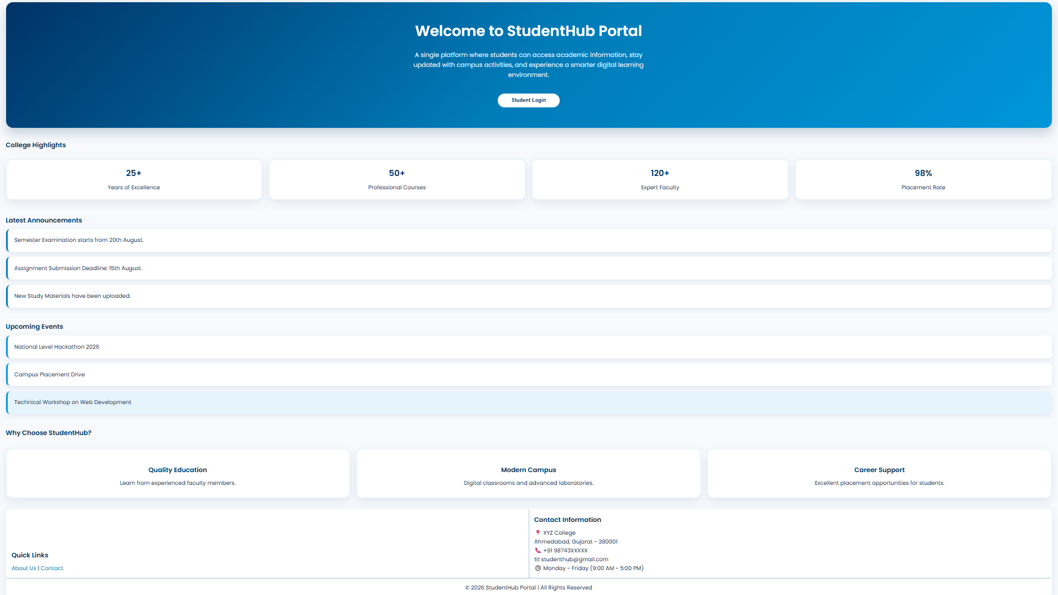
Figure 3.1: Home Page
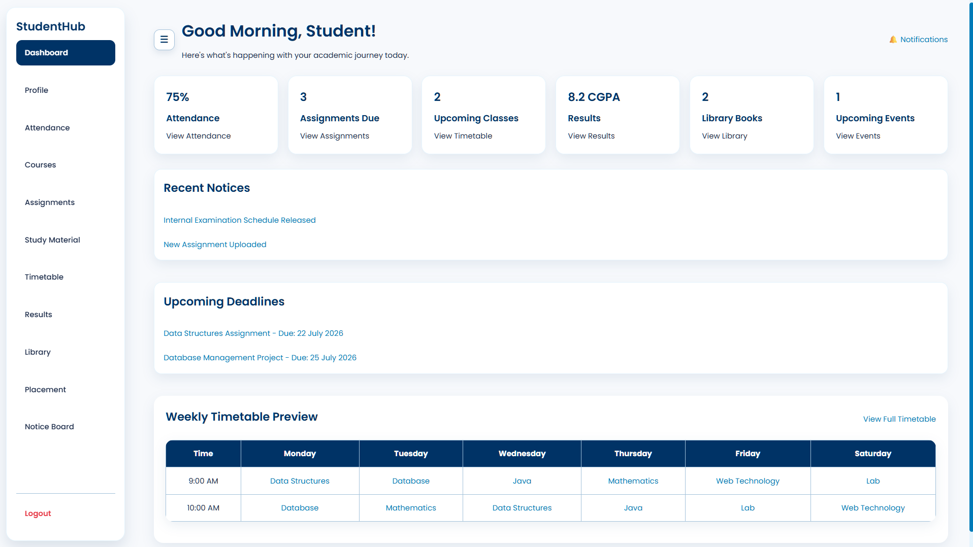
Figure 3.2: Dashboard Page
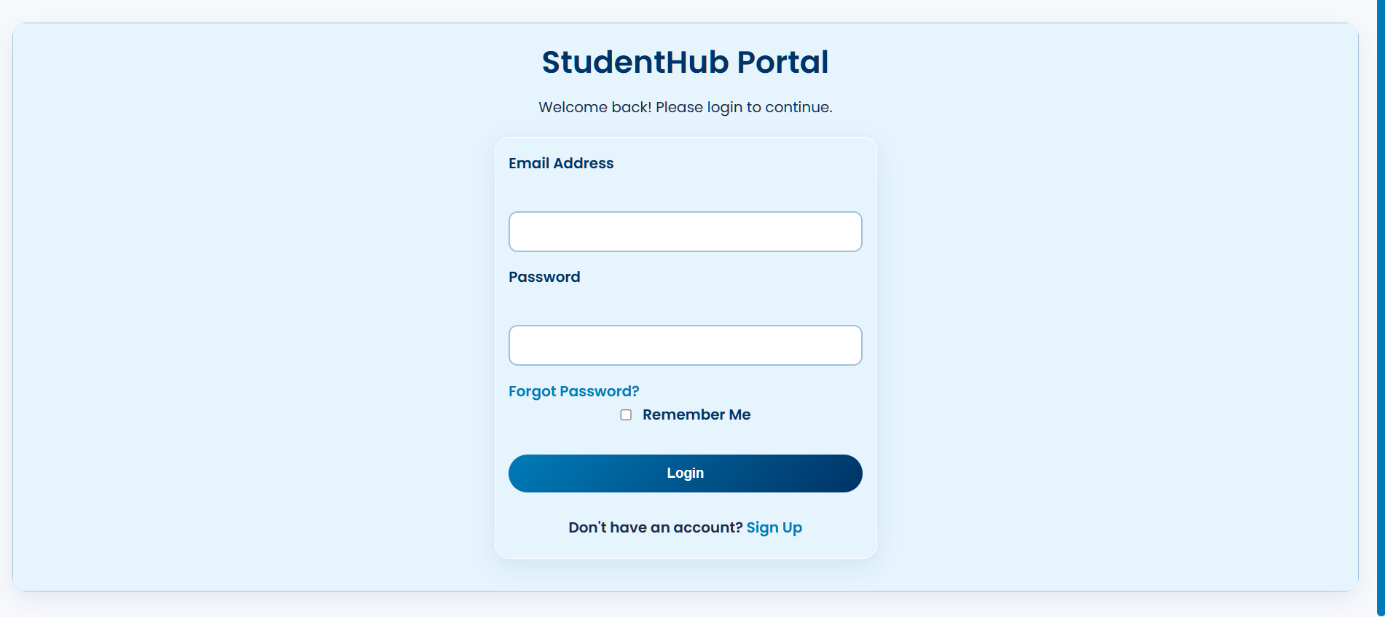
Figure 3.3: Login Page
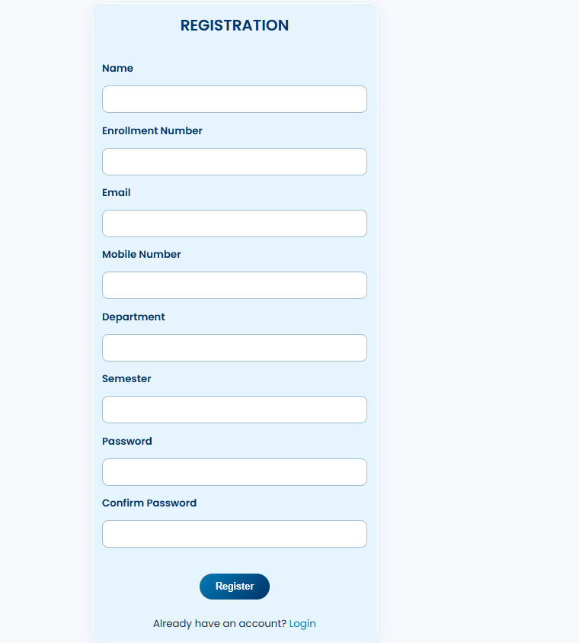
Figure 3.4: Register Page
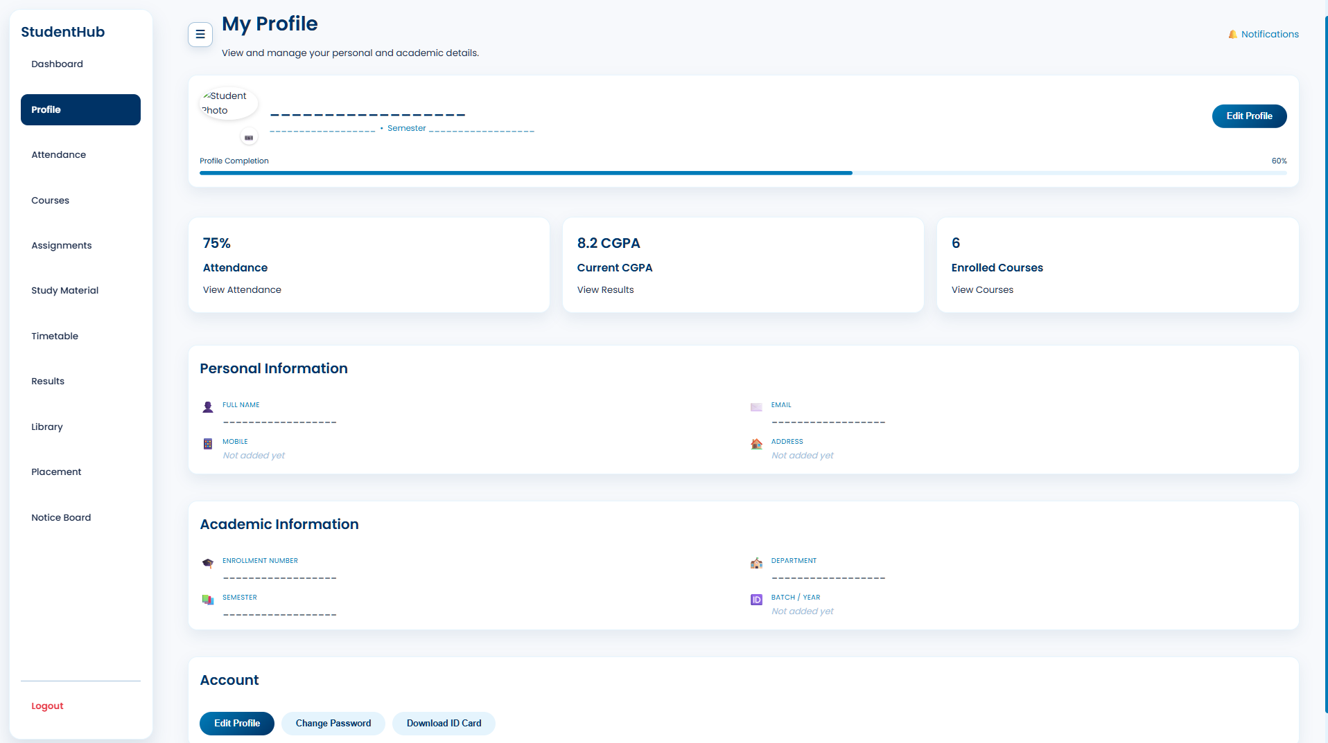
Figure 3.5: Profile Page
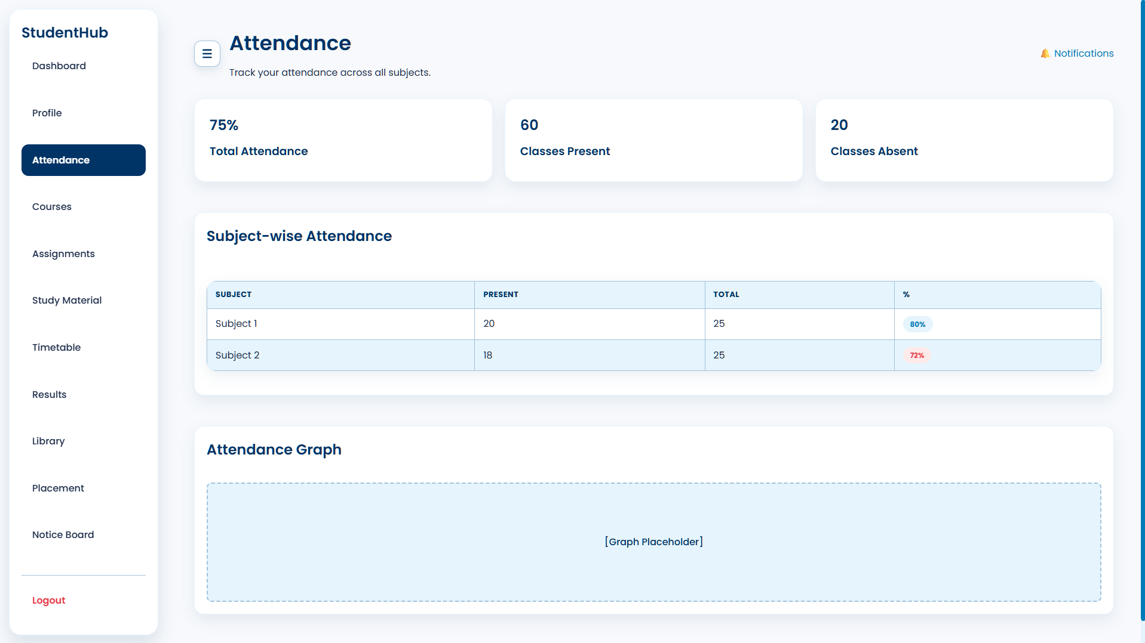
Figure 3.6: Attendance Page
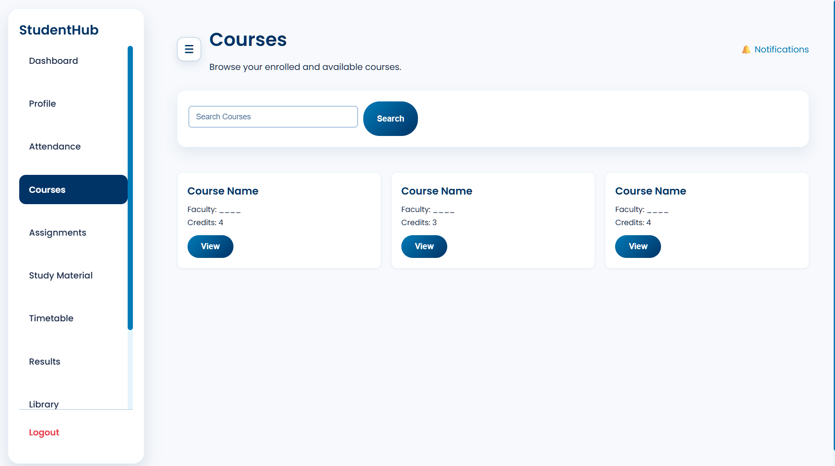
Figure 3.7: Courses Page
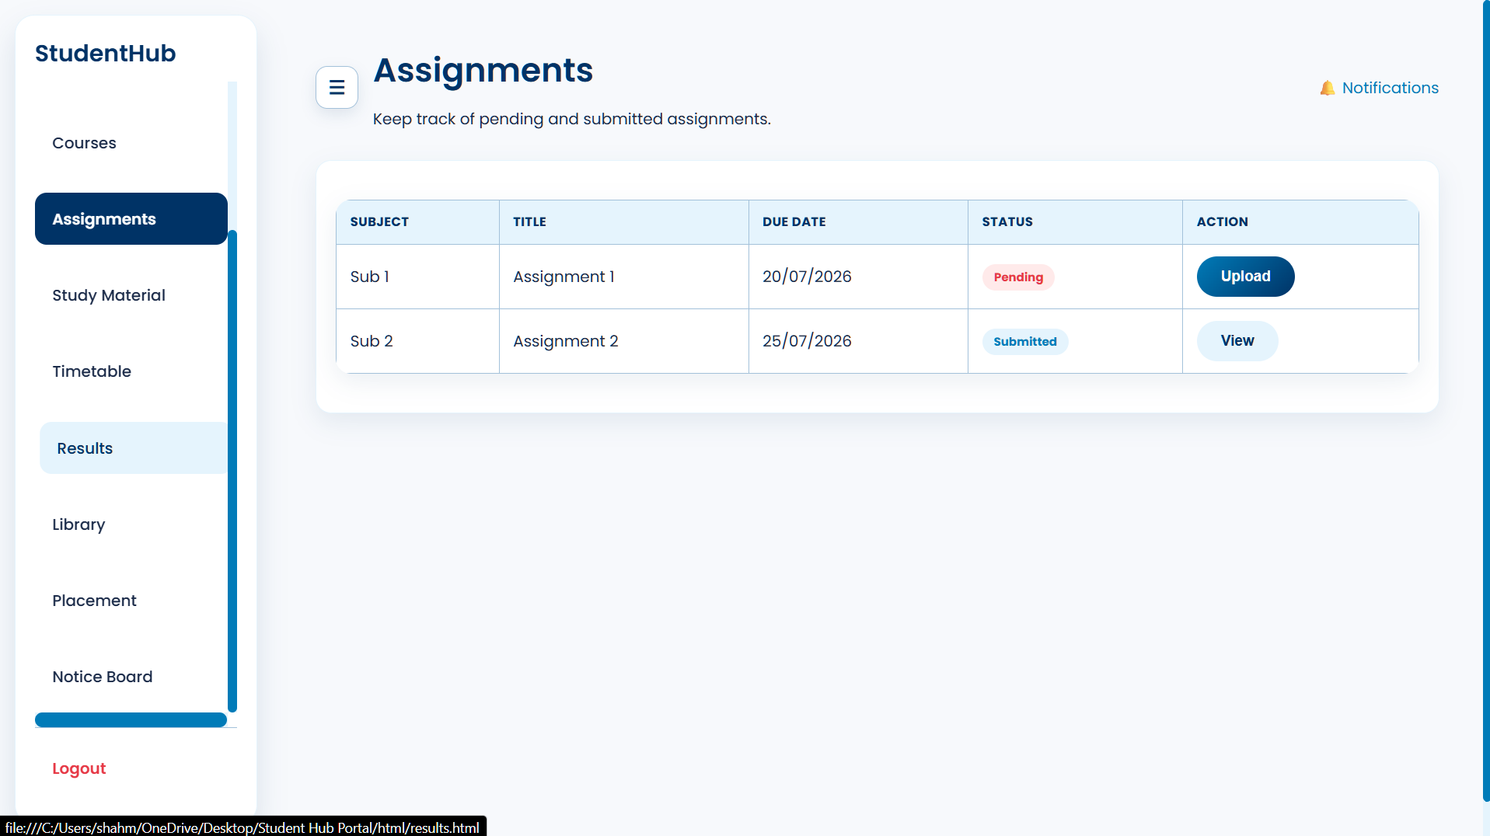
Figure 3.8: Assignments Page
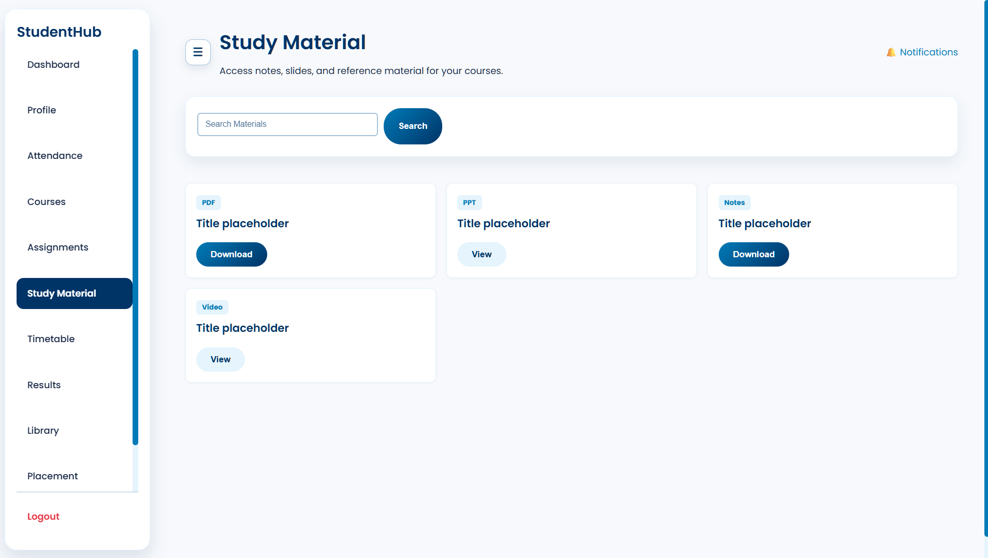
Figure 3.9: Study Material Page
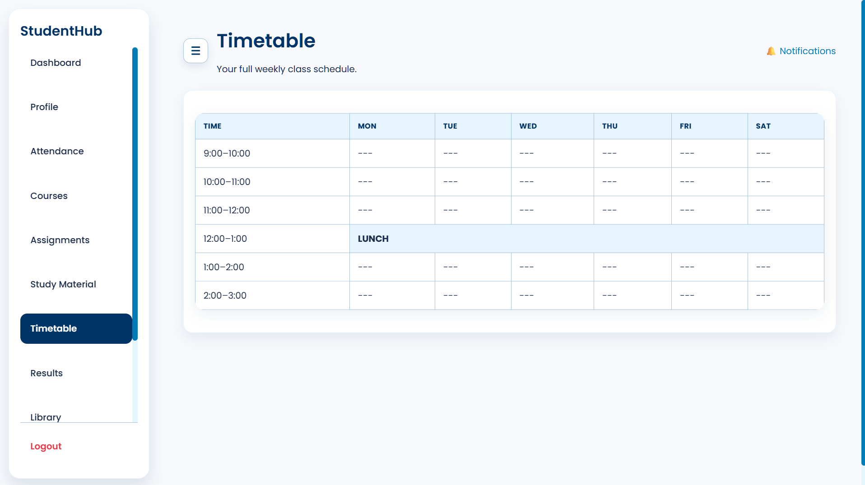
Figure 3.10: Timetable Page
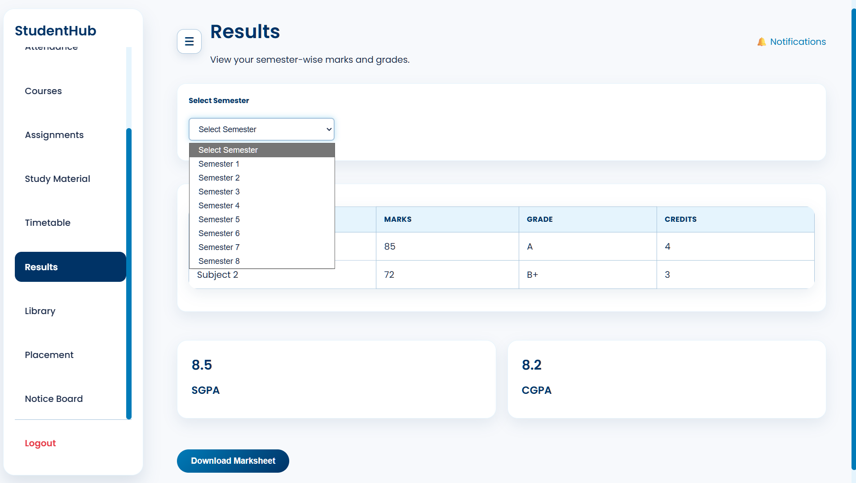
Figure 3.11: Results Page
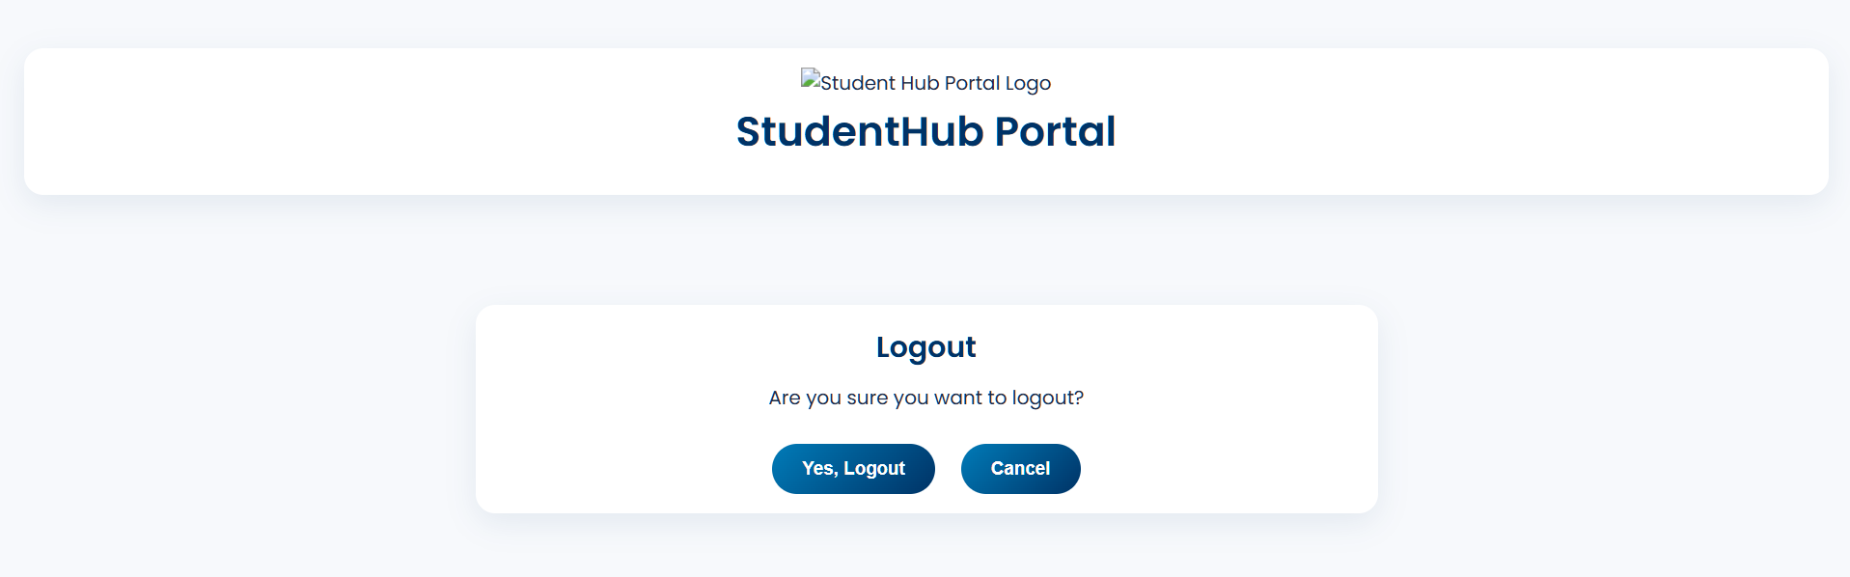
Figure 3.12: Logout Page

GitHub Repository Link: https://github.com/shahmahi0717/Student-Hub-Portal

Challenges Faced:
- Sidebar/Scroll Issue:
The sidebar links were not fitting properly and caused horizontal scrolling instead of staying within the sidebar. I had to adjust the sidebar width, overflow, spacing, and link alignment to make the navigation scroll vertically.
- Excessive CSS Code:
As I added styles for different pages and elements, the CSS file became very long and difficult to manage. Some properties were repeated unnecessarily, making the code harder to understand and maintain.
- Duplicate Code/Design:
Some elements had similar or duplicate CSS styles written separately. I had to identify common styles and combine them into reusable classes to avoid repeating the same design code.
- Element Arrangement:
Some elements were not positioned properly and overlapped or had uneven spacing. I had to adjust Flexbox, Grid, margins, and padding.
- Consistency:
Maintaining the same design, colours, fonts, and spacing across all StudentHub pages was challenging.

Learning Outcomes:
- Learned to create responsive web layouts using CSS Grid and Flexbox.
- Learned to use media queries for different screen sizes.
- Improved skills in spacing, alignment, colours, and typography.
- Learned to create mobile-first and user-friendly designs.
- Learned to maintain consistent styling across multiple pages.

Faculty Remarks: (Keep this blank for faculty)

